MySQL Assignment 1 -

DDL Commands, Constraints
Table created :
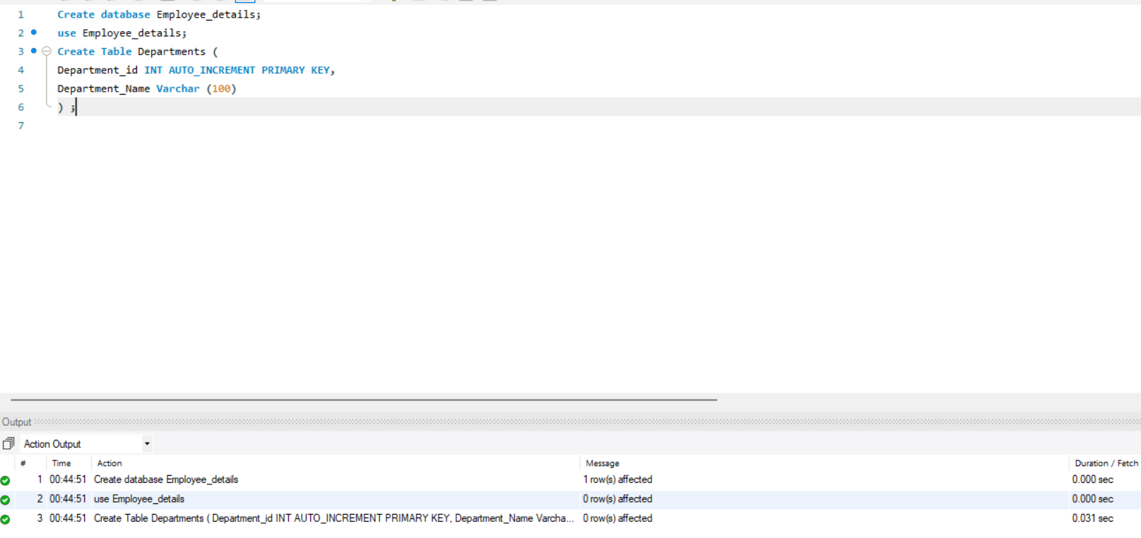
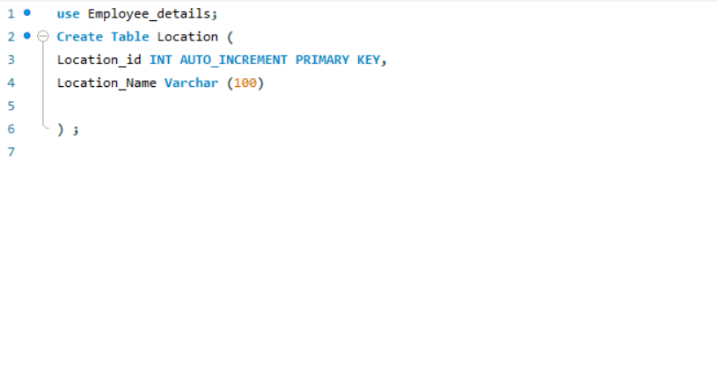
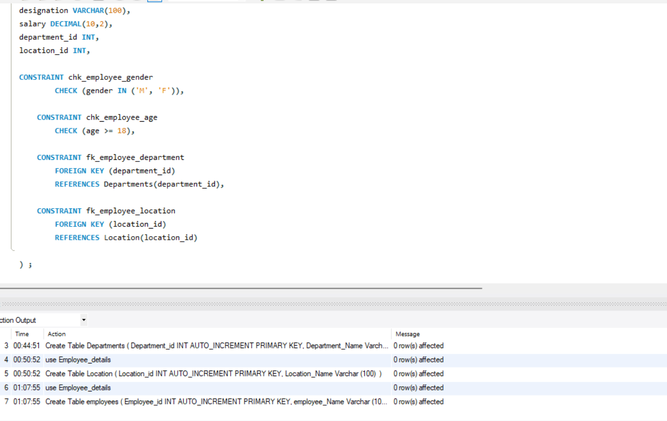
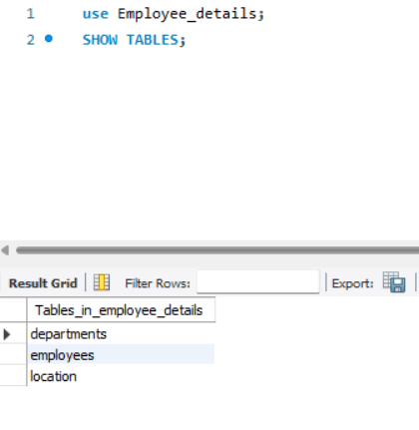

2. Table Alteration (ALTER)
Add a new column named "email" to the Employees table to store
employee email addresses.
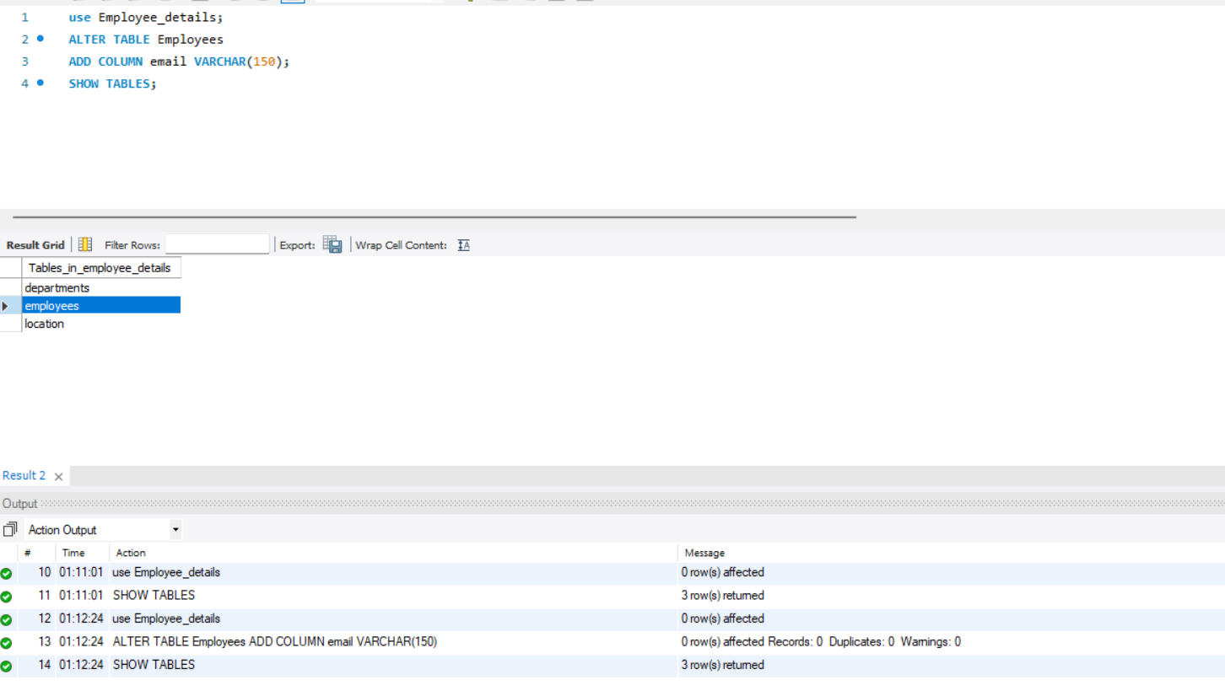
Modify the data type of the "designation" column in the Employees table to
support a wider range of values.
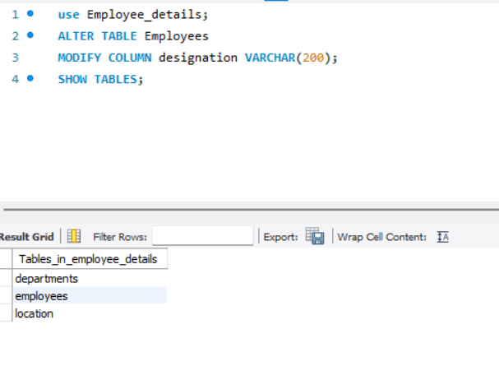
Drop the “age” column from the Employees table.
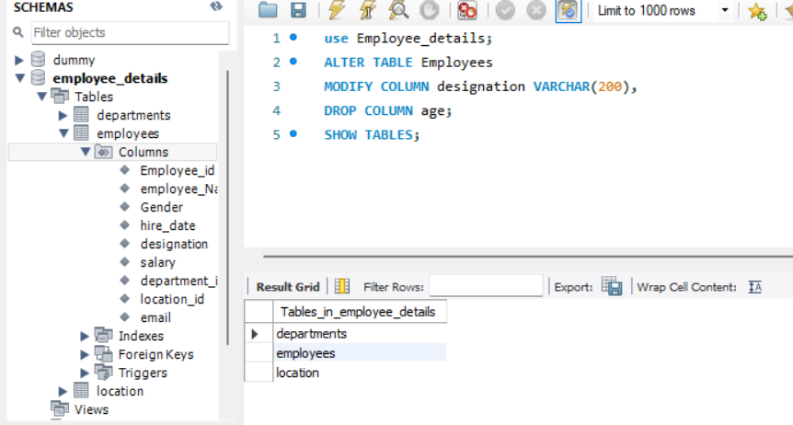
Rename the “hire_date” column to “date_of_joining”.
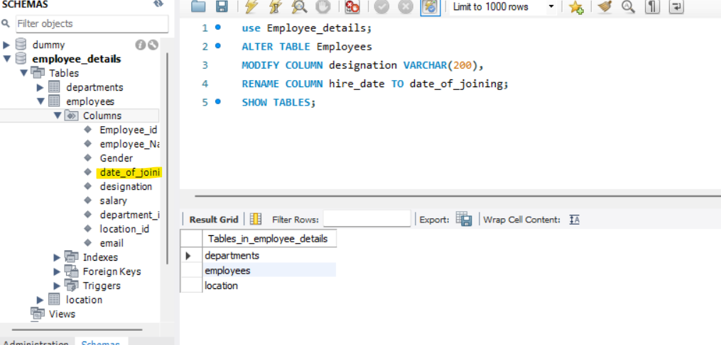
3. Table Renaming (RENAME):
Rename the "Departments" table to "Departments_Info".
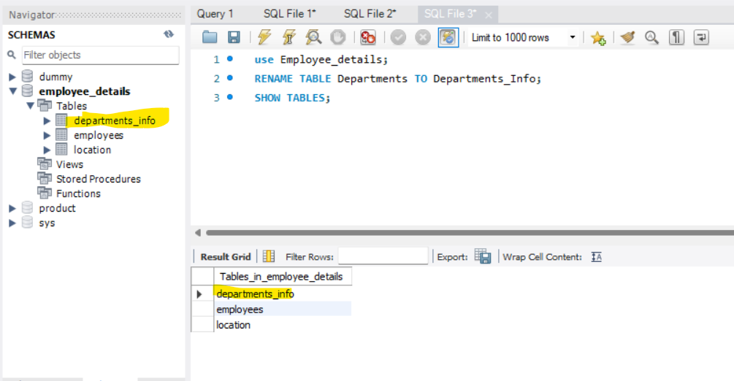
Rename the "Location" table to "Locations".
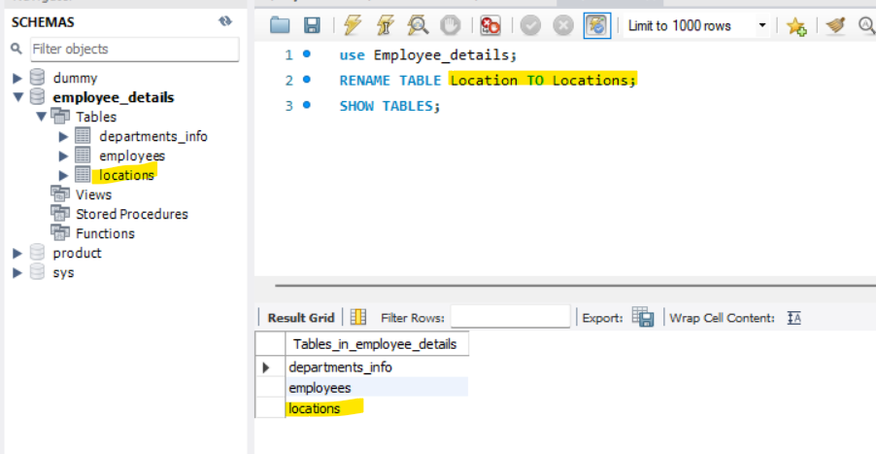
4. Table Truncation (TRUNCATE):
Truncate the Employees table.

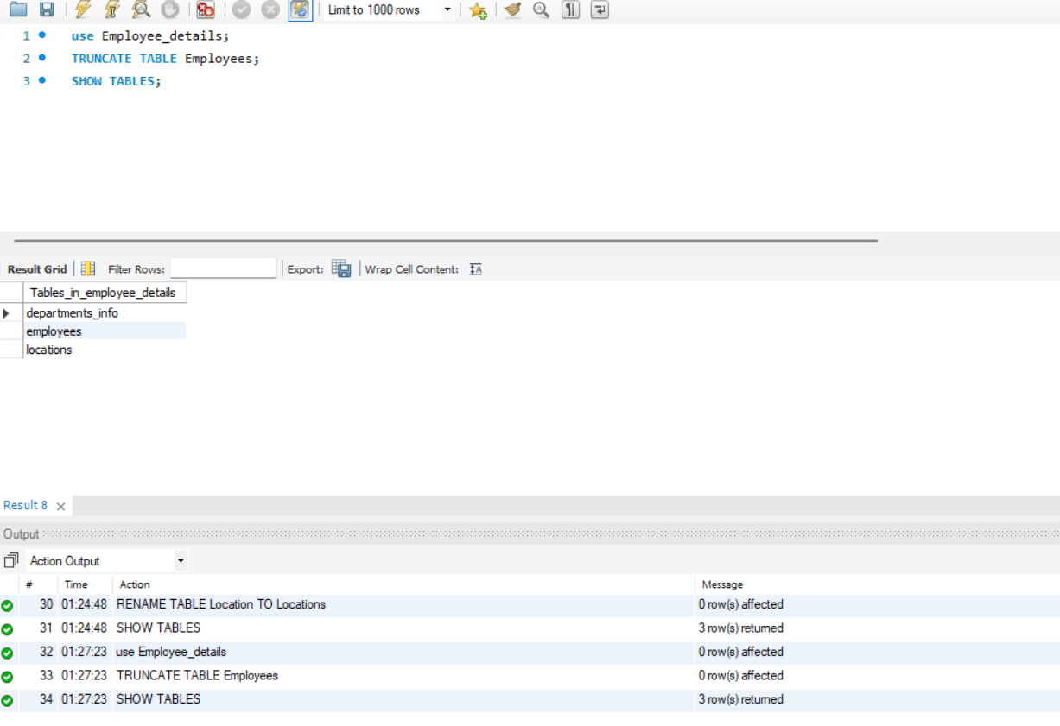
5. Database & Table Dropping (DROP):
Drop the Employees table and then the “employee” database.
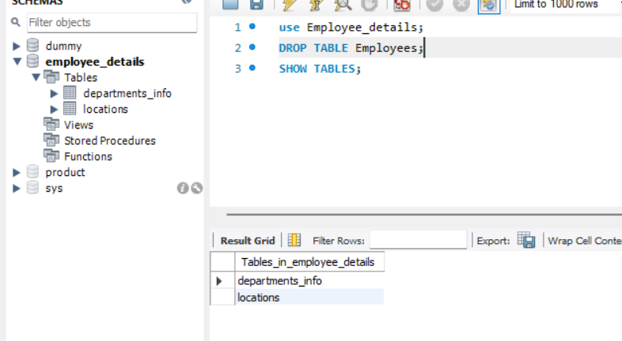
Tasks: Constraints
- Database Recreation:
Drop the 'employee' database if it exists
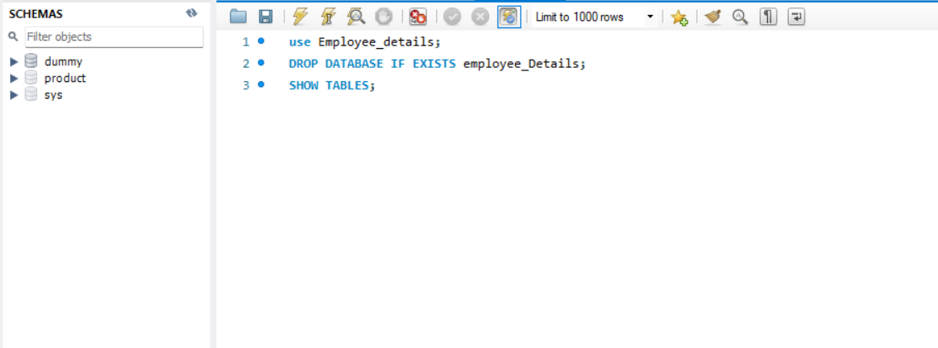
Recreate it using the provided schema, ensuring that all tables are created
with the appropriate constraints as instructed.
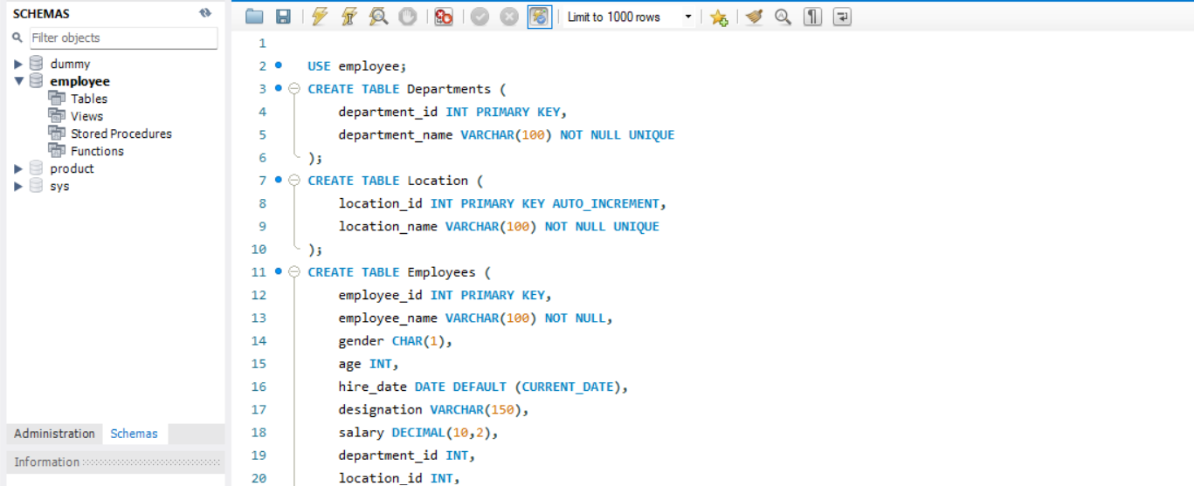

Establish links between the "department_id" and "location_id" fields in the
"employees" table and their respective tables.
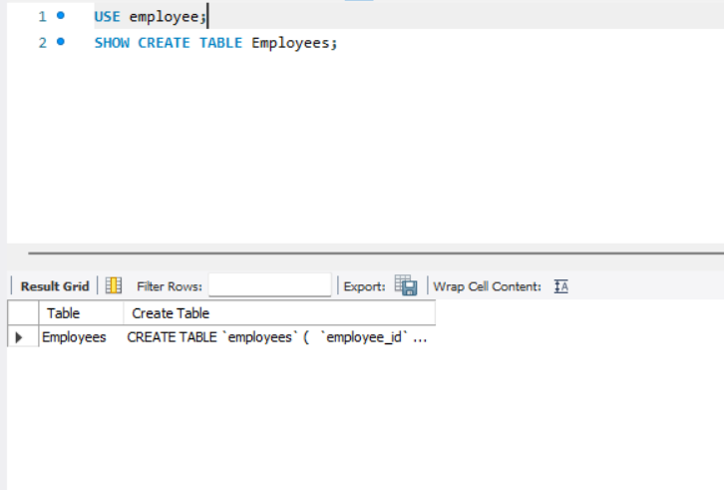
- Departments Table:
Ensure that the "department_id" uniquely identifies each department.
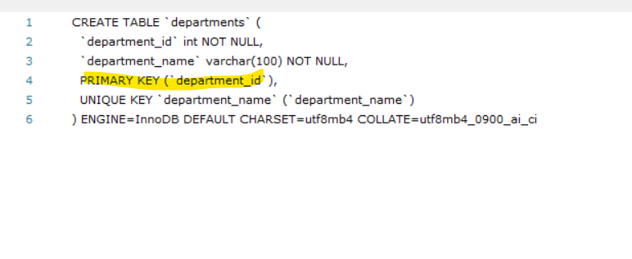
Set up constraints on the "department_name" to avoid duplicate and null
entries.
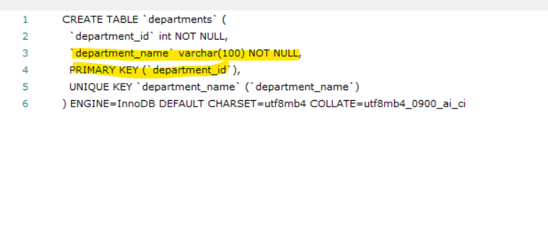
- Locations Table:
Establish a mechanism to automatically generate unique identifiers for each
location, ensuring that they are incremented sequentially.
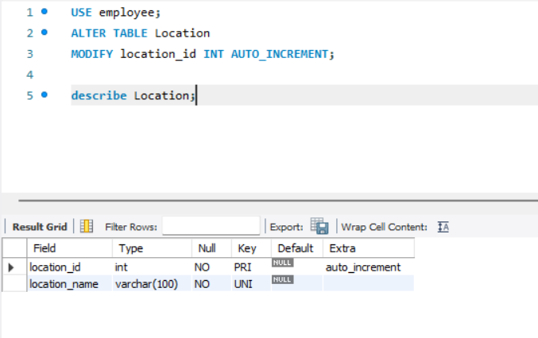
Implement constraints to prevent the insertion of null and duplicate locations.

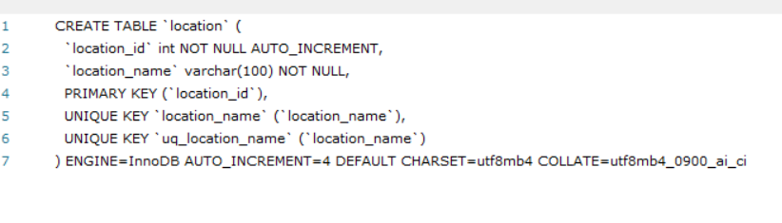
- Employees Table:
Guarantee that each employee has a distinct identifier.
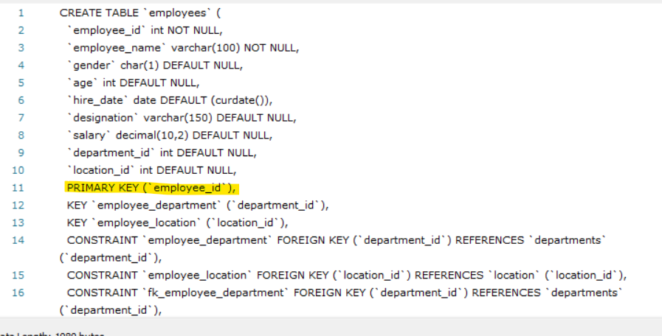
Create a restriction to ensure that the employee's name is always provided.
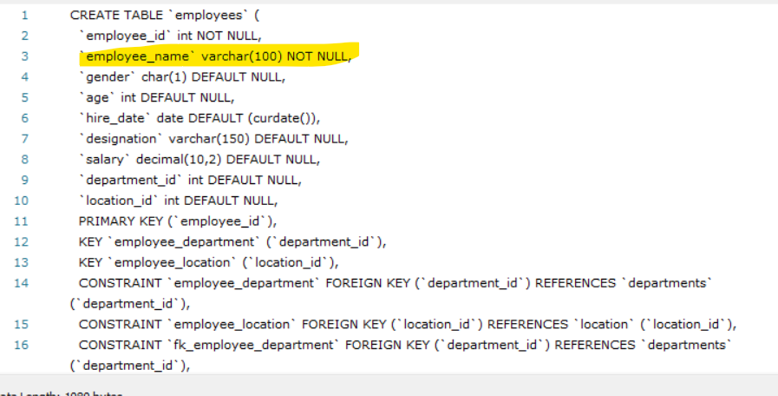
Limit the acceptable values for the "gender" field to only 'M' or 'F'.

Enforce a condition to ensure that the employee's age is 18 or above.
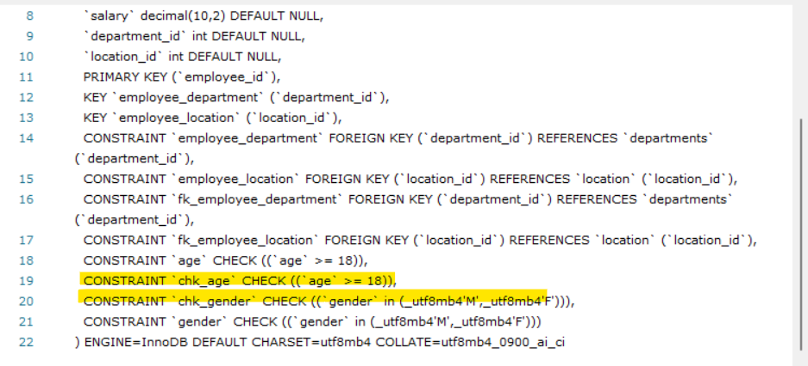
Automatically assign the current date to the "hire_date" field if not specified.
